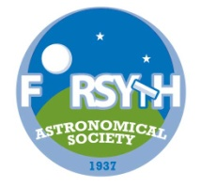 **Forsyth Astronomical Society**

**C:\Users\Marcia\AppData\Local\Microsoft\Windows\Temporary Internet Files\Content.IE5\PX9D6DPG\MC900324764[1].wmfTelescope** Buyers Clinic

**Saturday, September 27**

**Noon - 4:00pm**

***Free program***

**Held at SciWorks ⬩ 400 W. Hanes Mill Rd.**

**Winston-Salem, NC**

**Learn about:**

* **Binoculars for star gazing**
* **Telescopes for star gazing**
* **Star charts and Planispheres**
* **Astronomy Apps for smart phones and tablets**
* **Eyepieces and Filters for telescopes**
* **Advance topics including solar observing and astrophotography**

For more Information check the **FAS37.org** website!

Weather permitting; there may be telescopes outside for solar viewing during the program.

**FAS37.org**  [](https://si0.twimg.com/profile_images/3513354941/24aaffa670e634a7da9a087bfa83abe6.png) [Twitter](http://cs.thomsonreuters.com/twitter/) [Follow iMore on Google+](https://plus.google.com/b/118265535124242676853/)  **Forsyth Astronomical Society**